CmpE 150 Project 2
Project Report
Problem Description:
Writing a java program that plays Tic-Tac-Toe game in two different ways. There are two players in the game. One player will be the user and the other player will be the computer. Firstly, user will be asked if he/she wants to load the board from a file or create a new empty board. There are two different method that can run according to decision of player. Empty cells are denoted with the E symbol. Each cell of the board can be identified with coordinates as first coordinate is the row number and second coordinate is the column number. The cell in the top left corner has coordinate (1, 1) whereas the lower right corner has coordinates (4, 4). For example, bottom left corner has coordinate (4, 1). When printing the board to the screen, there should be only one space before and after the symbols. Program will ask the user if he/she wants to play as ‘X’ or ‘O’ and the computer will play as the opposite side. Choosing the starting player will be decided randomly. Game will continue until one player wins. Winning conditions are having three consecutive X’s or O’s horizontally, vertically, or diagonally. The game may also end in a tie, which is the condition that neither of the players win.
Problem Solution:
To write tic-tac-toe game I use seven static method besides main method. I used fourteen while loops, fifty-three if statement, eleven for loop and four try-catch statements.
First method was loadFile method. This method starts to run when user decides to play game from a file. First while loop return just once. I used this while loop because there are some places that I used break and continue statements. Second while loop controls whether entered file exists or not. It returns until the given file exists. Third while loop checks whether given file name is a file or not. After these statements file can be read and next while loop starts to write contexts of file in a string. My sample table consist of four lines so for loop return three times and then read last line. Thus, I prevent another empty line. In here if statement checks whether given file is possible table or not. If table is impossible continue statement return code to first while loop. If table is possible the code continues properly. Now it checks whether this file is already ended or not. If this file already ended create method starts to execute its statements. If given file is not a complete file, file loaded successfully and ready to play. In here while loop checks whether entered input is X or O. If it’s not loop asks a new input from user. Then continues to run. Upcoming two if statement determine the mark of player and computer. The other upcoming three if statements checks the number of X’s and O’s. If one is greater than other the player who has smaller mark starts to game. If the number marks are equal beginner chosen randomly. Now program checks whether there is tie or not. If there is a tie program asks whether he/she wants to play again. If user choose yes new empty table created and starts a new game in create method. If not, scoreboard printed on screen and program stops. New if statement checks whether there is a win situation or not. If there is no winner program asks user a coordinate and prints table. After that computer plays and tie and win condition checks again and again and so on.
Second method is create method. It runs only if user wants to play an empty table at the beginning. First while loop execute its statements if the user wants to play again. Second while loop checks marks. In here while loop checks whether entered input is X or O. If it’s not loop asks a new input from user. Then continues to run. Upcoming two if statements determines marks. And then other if statements decide beginner randomly. There is a try-catch statement to input mismatch. New while loop controls whether there is a winner or not. If there is no winner this loop returns until there is one. New if statement checks coordinates validity. If coordinates are not valid program asks new coordinates from user. Other two if statements check whether there is a winner or not and whether there is a tie situation or not. If there is a tie program asks user playing again. If user wants program starts from beginning. If not, program stops and print score board. Last if statements control whether player wants to play again or not. If user wants to play again program returns first while loop in create method. If not, program ends and print scoreboard.
Third method is computer method. Computer’s moves planned here. Coordinates chosen randomly in here. If chosen coordinates places are not empty while loop chose new coordinate randomly again. And then makes the changes in table and return table.
Fourth method is checkForWin method. In here program’s control mechanism created. For loops checks in order horizontally vertically diagonally and reverse diagonally. If consecutive three cells are same and not E there is a winner. If there is a winner program returns false. If not vice versa can be said.
Fifth method impossible board method. For loops checks every row and column. If cells include other than X O E method returns false. If spaces and ‘|’ is in wrong place program returns false again. If the difference between the number of X’s O’s greater than 1 program returns false. Thus, I can detect impossible board.
Sixth method is checkForTie method. In here I can detect tie situations. For loops travel inside table and checks all cells. If all cells are not empty and there is no winner program returns true. Thus, tie situation occurs.
Last method is main method. Here I just decide whether player wants to load a file or create a new empty string. If user chose L loadFile method starts to run. If user chose C new empty String created and create method starts to run.

Implementation:

import java.io.File;
import java.io.FileNotFoundException;
import java.util.Random;
import java.util.Scanner;

public class MG2017400162 {
public static int count = 0;// This variable stores the number of computer wins.
public static int count1 = 0;// This variable stores the number of player wins.
public static int markCount = 0;// This variable stores the number of 'X' when checking impossible board.
public static int markCount1 = 0;// This variable stores the number of 'O' when checking impossible board.

public static void main(String[] args) throws FileNotFoundException {
Scanner console = new Scanner(System.in);
System.out.println("Welcome to the XOX Game. ");
System.out.print("Would you like to load the board from file or create a new one? (L or C) ");
String choice = console.next();// This variable stores the player's choice whether loading from a file or not.
choice = choice.toUpperCase();// To prevent errors this statement convert letter to upper case.
while(!choice.equals("L") && !choice.equals("C")) {// If player enters anything except L or C this method ask again player's choice.
System.out.print("Wrong input! Try again: ");
choice = console.next();
choice = choice.toUpperCase();
}
if (choice.equals("L")) {// If choice is L loadFile method start to execute its statements.
loadFile(console);
}
else if (choice.equals("C")) {// If choice is C create method start to execute its statements.
create(console);
}
System.out.println("Thanks for playing.");
}

public static void loadFile(Scanner console) throws FileNotFoundException {//if player decides to load file this method will run
Random rand = new Random();
int r = 0;// It represents row
int c = 0;// It represents column
int k = 0;// Just in case of control for win conditions.
String again= "Y";//this represent the choice of whether player wants to play again or not
String newTable ="";//this holds the context of file
String table ;//this holds the board
int n = 0;//just for running while loop for once.
while(n==0) {
System.out.print("Please enter the file name: ");
String file = console.next();//file name
File fileBoard = new File(file);
while(!fileBoard.exists()) {//checks whether this file exists or not
System.out.println("Such a file does not exist! ");//ıf file does not exist this statement executes.
System.out.print("Please enter the file name: ");
file = console.next();//ıt will read file name again
fileBoard = new File(file);
}
while(!fileBoard.isFile()) {//it checks whether this is a file or not
System.out.println("Such a file does not exist! ");//ıf file does not exist this statement executes.
System.out.print("Please enter the file name: ");
file = console.next();//ıt will read file name again
fileBoard = new File(file);
}
Scanner fileScan = new Scanner(fileBoard);//this scanner for reading file context
newTable ="";//empty string for table
while(fileScan.hasNextLine()) {//if file has next line this loop continues to return
for(int m=0;m<3;m++) {//my file consist of 4 lines so this loop return 3 times and then read last line
newTable+=fileScan.nextLine();//this statement reads each line and add to new table
newTable+="\n";
}
newTable+=fileScan.nextLine();
}
table = newTable;
if(!impossibleBoard(table)) {//it checks whether this board possible or not
System.out.println("Impossible board configuration! ");
continue;
}
else {
if(!checkForWin(table)) {//it checks whether there is a win or not in loaded file
System.out.println(table);
System.out.println("Game has already ended!");
create(console);//then it create an empty board to play again
n=1;
}
else {//if there is no problem such as impossible board or any win condition program start to continue properly
System.out.println("Load successful. ");
System.out.print("Enter your symbol: (X or O) ");//it asks player's mark
String mark = console.next();
mark = mark.toUpperCase();
String mark1 = "";//computer's mark
while(!mark.equals("X") && !mark.equals("O")) {//if player enters anything except X and O program give an error and asks again
System.out.print("Wrong input! Try again: ");
mark = console.next();
mark = mark.toUpperCase();
}
if(mark.equals("X")) {//if mark equals X computer's mark become O
mark1 = "O";
System.out.print("You are player " + mark + " and the computer is player "+ mark1 + ". \n");
}
else if (mark.equals("O")){//if mark equals O computer's mark become X
mark1 = "X";
System.out.print("You are player " + mark + " and the computer is player " +mark1 + ". \n");
}
if(markCount==markCount1+1) {//if the number of X's one greater than O's and player's mark equals X computers starts the game
if(mark.equals("X")) {
System.out.println("Computer will start: ");
table=computer(r,c,rand,table,mark1,mark);//this statement calls computer method and computer plays here
System.out.println(table);
}
else {//if the number of X's one greater than O's and player's mark equals O player starts the game
System.out.println("You will start: ");
System.out.println(table);
}
}
else if(markCount1==markCount+1) {//if the number of O's one greater than X's and player's mark equals O computers starts the game
if(mark.equals("O")) {
System.out.println("Computer will start: ");
table=computer(r,c,rand,table,mark1,mark);//this statement calls computer method and computer plays here
System.out.println(table);
}
else {//if the number of O's one greater than X's and player's mark equals X computers starts the game
System.out.println("You will start: ");
System.out.println(table);
}
}
else if(markCount1==markCount){//if the number of O's equal to number of X's than the beginner who starts the game decided randomly
int starter = rand.nextInt(2);//it gives randomly two number 0 and 1
if (starter==1) {//if the number equals to 1 then computer starts
System.out.println("Computer will start: ");
table=computer(r,c,rand,table,mark1,mark);//this statement calls computer method and computer plays here
System.out.println(table);//it prints table
}
else {//if number is zero than player starts
System.out.println("You will start: ");
System.out.println(table);
}
}
if (checkForTie(table)) {//after the player move program check again whether there is a tie or not
System.out.print("There has a tie!!! Do you want to play again? (Y or N) ");//this statement ask player wants to play again or not
again = console.next();//it holds player choice about playing again Y represents yes N represents No
again = again.toUpperCase();
if(again.equals("N")) {//if choice equals N program stops
System.out.println("You: " + count1 + " Computer: " + count);//then print scoreboard
}
else if(again.equals("Y")) {//if choice equals Y program creates an empty board and continues
create(console);
}
break;
}
if(!checkForWin(table)) {//after the player move program check again whether there is a win or not
k=1;//just handle if statements easily
if (k==1) {
System.out.print("Computer wins! Do you want to play again? (Y or N) ");//this statement ask player wants to play again or not
count++;// this holds the number of computer wins
}
again = console.next();//it holds player choice about playing again Y represents yes N represents No
again = again.toUpperCase();
if(again.equals("N")) {//if choice equals N program stops
System.out.println("You: " + count1 + " Computer: " + count);//then print scoreboard
}
else if(again.equals("Y")) {//if choice equals Y program creates an empty board and continues
create(console);
}
}
else {//if there is no tie or win than this statement start to execute its statements
System.out.print("Enter coordinates: ");//asks player to enter coordinates for a new move
while(true) {//if player enters a string or anything other than integer this loop prevent a runtime error and prints wrong input
try {
r = console.nextInt();//takes input from player for row coordinate
c = console.nextInt();//takes input from player for column coordinate
break;
}catch(Exception ex) {//if there is a exception these statements executes
System.out.println("Wrong input! Try again: ");
console.nextLine();
continue;
}
}

while(checkForWin(table)) {//while there is no win program continues to running
k = 0;
if(((r<1 || r>4) || (c<1 || c>4)) || table.charAt((18*(r-1)+(4*c-2)))!='E'){//if player enters invalid input such as if r and c
//coordinates range is out of 1-4 and if there is anything than E program give wrong input and asks again
System.out.print("Wrong input! Try again: ");
r = console.nextInt();//takes input from player for row coordinate
c = console.nextInt();//takes input from player for column coordinate
continue;
}
table = table.substring(0,18*(r-1)+(4*c-2))+mark+ table.substring(18*(r-1)+(4*c-1));//player's move executes here and table configuration
//changes here
if (checkForTie(table)) {//after the player move program check again whether there is a tie or not
System.out.print("There has a tie!!! Do you want to play again? (Y or N)");//this statement ask player wants to play again or not
k=-1;//just handle if statements easily
break;
}
if(checkForWin(table)) {//after the player move program check again whether there is a win or not
table=computer(r,c,rand,table,mark1,mark);//this statement calls computer method and computer plays here
k =1;//just handle if statements easily
}
if (checkForTie(table)) {//after the player move program check again whether there is a tie or not
System.out.println(table);
System.out.print("There has a tie!!! Do you want to play again? (Y or N)");//this statement ask player wants to play again or not
k=-1;//just handle if statements easily
break;
}
System.out.println(table);
if (checkForWin(table)) {//after the computer move program check again whether there is a win or no
System.out.print("Enter coordinates: ");
while(true) {//if player enters a string or anything other than integer this loop prevent a runtime error and prints wrong input
try {
r = console.nextInt();//takes input from player for row coordinate
c = console.nextInt();//takes input from player for column coordinate
break;
}catch(Exception ex) {//if there is a exception these statements executes
System.out.println("Wrong input! Try again: ");
console.nextLine();
continue;
}
}
}
else {
break;//if there is no tie or winner program returns the beginning of while loop and executes its statement again
}
}
if (k==1) {//just handle if statements easily
System.out.print("Computer wins! Do you want to play again? (Y or N) ");//this statement ask player wants to play again or not
count++;// this holds the number of computer wins
}else if(k==-1) {//just handle if statements easily

}
else {
System.out.print("You win! Do you want to play again? (Y or N) ");//this statement ask player wants to play again or not
count1++;// this holds the number of player's wins
}
again = console.next();//it holds player choice about playing again Y represents yes N represents No
again = again.toUpperCase();
if(again.equals("N")) {//if choice equals N program stops
System.out.println("You: " + count1 + " Computer: " + count);//then print scoreboard
}
else if(again.equals("Y")) {//if choice equals Y program creates an empty board and continues
create(console);
}
n=1;//just handle while loop to run just once
}
}
}
}
}

public static void create(Scanner console) {//this method creates empty table
String again= "Y";//just for running while loop in the beginning
while(again.equals("Y")) {//if player's choice equals Y this loop starts execute its statements
System.out.print("Enter your symbol: (X or O) ");//it asks player's mark
String mark = console.next();
mark = mark.toUpperCase();
String mark1 = "";//computer's mark
while(!mark.equals("X") && !mark.equals("O")) {//if player enters anything except X and O program give an error and asks again
System.out.print("Wrong input! Try again: ");
mark = console.next();
mark = mark.toUpperCase();
}
if(mark.equals("X")) {//if mark equals X computer's mark become O
mark1 = "O";
System.out.print("You are player " + mark + " and the computer is player "+ mark1 + ". \n");
}
else if (mark.equals("O")){//if mark equals O computer's mark become X
mark1 = "X";
System.out.print("You are player " + mark + " and the computer is player " +mark1 + ". \n");
}
int r=0,c=0;
String table = "| E | E | E | E |\n| E | E | E | E |\n| E | E | E | E |\n| E | E | E | E |";//empty table
Random rand = new Random();
int starter = rand.nextInt(2);//it gives randomly two number 0 and 1
if (starter==1) {//if the number equals to 1 then computer starts
System.out.println("Computer will start: ");
table=computer(r,c,rand,table,mark1,mark);//this statement calls computer method and computer plays here
System.out.println(table);//it prints table
}
else {//if number is zero than player starts
System.out.println("You will start: ");
System.out.println(table);
}
System.out.print("Enter coordinates: ");//asks player new coordinates
while(true) {//if player enters a string or anything other than integer this loop prevent a runtime error and prints wrong input
try {
r = console.nextInt();//takes input from player for row coordinate
c = console.nextInt();//takes input from player for column coordinate
break;
}catch(Exception ex) {//if there is a exception these statements executes
System.out.println("Wrong input! Try again: ");
console.nextLine();
continue;
}
}
int k = 0;
while(checkForWin(table)) {//while there is no win program continues to running
k = 0;
if(((r<1 || r>4) || (c<1 || c>4)) || table.charAt((18*(r-1)+(4*c-2)))!='E'){//if player enters invalid input such as if r and c
//coordinates range is out of 1-4 and if there is anything than E program give wrong input and asks again
System.out.print("Wrong input! Try again: ");
r = console.nextInt();//takes input from player for row coordinate
c = console.nextInt();//takes input from player for column coordinate
continue;
}
table = table.substring(0,18*(r-1)+(4*c-2))+mark+ table.substring(18*(r-1)+(4*c-1));//player's move executes here and table configuration changes here
if (checkForTie(table)) {//after the player move program check again whether there is a tie or not
System.out.print("There has a tie!!! Do you want to play again? (Y or N)");//this statement ask player wants to play again or not
break;
}
if(checkForWin(table)) {//after the player move program check again whether there is a win or not
table=computer(r,c,rand,table,mark1,mark);//this statement calls computer method and computer plays here
if (checkForTie(table)) {//after the computer's move program check again whether there is a tie or not
System.out.println("There has a tie!!!");
break;
}
else {
k =1;
}
}
System.out.println(table);
if (checkForWin(table)) {//after the computer move program check again whether there is a win or not
System.out.print("Enter coordinates: ");//asks player new coordinates
while(true) {//if player enters a string or anything other than integer this loop prevent a runtime error and prints wrong input
try {
r = console.nextInt();//takes input from player for row coordinate
c = console.nextInt();//takes input from player for column coordinate
break;
}catch(Exception ex) {//if there is a exception these statements executes
System.out.println("Wrong input! Try again: ");
console.nextLine();
continue;
}
}
}
else {
break;//if there is no tie or winner program returns the beginning of while loop and executes its statement again
}
}
if (k==1) {//just handle if statements easily
System.out.print("Computer wins! Do you want to play again? (Y or N) ");//this statement ask player wants to play again or not
count++;// this holds the number of computer wins
}
else {
System.out.print("You win! Do you want to play again? (Y or N) ");//this statement ask player wants to play again or not
count1++;// this holds the number of player's wins
}
again = console.next();//it holds player choice about playing again Y represents yes N represents No
again = again.toUpperCase();
if(again.equals("N")) {//if choice equals N program stops
System.out.println("You: " + count1 + " Computer: " + count);//then print scoreboard
}
}
}

public static String computer(int r, int c, Random rand, String table, String mark1,String mark) {//computer makes its whole move and work here
r = rand.nextInt(4)+1;//random row coordinate its range is 1-4
c = rand.nextInt(4)+1;//random column coordinate its range is 1-4
while(table.charAt(18*(r-1)+(4*c-2))!='E') {//if randomly chosen coordinate's place includes other than E this loop select new coordinate
r = rand.nextInt(4)+1;//random row coordinate its range is 1-4
c = rand.nextInt(4)+1;//random column coordinate its range is 1-4
}
table = table.substring(0,18*(r-1)+(4*c-2))+mark1+ table.substring(18*(r-1)+(4*c-1));//table changes here computer makes its move here
return table;//returns table
}

public static boolean checkForWin(String table) {//control function for win conditions
int sum=0;//if there is any win situation this variable changes
for(int i = 0; i<4;i++) {//this for loop returns 4 times (4 represents total row number)
if((table.charAt(18*i+2)!='E' && table.charAt(18*i+2)==table.charAt(18*i+6) && table.charAt(18*i+6)==table.charAt(18*i+10)) ||
(table.charAt(18*i+6)!='E' && table.charAt(18*i+6)==table.charAt(18*i+10) && table.charAt(18*i+10)==table.charAt(18*i+14))) {
//this if statement checks just horizontal wins
sum +=1;//if there is any win situation sum rises one
}
}
for(int i=0; i<2;i++) {
for(int k=2;k<15;k+=4) {
if(table.charAt(18*i+k)!='E' && table.charAt(18*i+k)==table.charAt(18*(i+1)+k) && table.charAt(18*(i+1)+k)==table.charAt(18*(i+2)+k)){
//this if statement checks just vertical wins
sum +=1;//if there is any win situation sum rises one
}
}
}
for(int i=0; i<2;i++) {
if((table.charAt(18*i+2)!='E' && table.charAt(18*i+2)==table.charAt(18*(i+1)+6) && table.charAt(18*(i+1)+6)==table.charAt(18*(i+2)+10)) ||
(table.charAt(18*i+6)!='E' && table.charAt(18*i+6)==table.charAt(18*(i+1)+10) && table.charAt(18*(i+1)+10)==table.charAt(18*(i+2)+14))) {
//this if statement checks just diagonal wins
sum +=1;//if there is any win situation sum rises one
}
}
for(int i=0;i<2;i++) {
if((table.charAt(18*i+14)!='E' && table.charAt(18*i+14)==table.charAt(18*(i+1)+10) && table.charAt(18*(i+1)+10)==table.charAt(18*(i+2)+6)) ||
(table.charAt(18*i+10)!='E' && table.charAt(18*i+10)==table.charAt(18*(i+1)+6) && table.charAt(18*(i+1)+6)==table.charAt(18*(i+2)+2))) {
//this if statement checks just reverse diagonal wins
sum +=1;//if there is any win situation sum rises one
}
}
if(sum==0) {//if there is no win method returns true
return true;
}
else {//if there is a win method returns false
return false;
}
}

public static boolean impossibleBoard(String table) {//this method checks whether loaded file is possible valid board or not
int sum=0;
markCount = 0;// This variable stores the number of 'X' when checking impossible board.
markCount1 = 0;// This variable stores the number of 'O' when checking impossible board.
int diff = 0;//the difference between the number of X's and the number of O's
for(int i=0;i<4;i++) {//this for loop returns 4 times (4 represents total row number)
for(int k=2;k<=16;k+=4) {//for moving in rows
if(table.charAt(18*i+k)!='X' && table.charAt(18*i+k)!='O' && table.charAt(18*i+k)!='E') {//if there are any other character except X O E sum rises once
sum++;
}
}
for(int l=0;l<=16;l+=4) {//for moving in rows
if(table.charAt(18*i+l)!='|') {//if there are anything other than | sum rises once
sum++;
}
}
for(int n=1;n<=16;n+=2) {//for moving in rows
if(table.charAt(18*i+n)!=' ') {//if there are anything other than ' '(space) sum rises once
sum++;
}
}
for(int k=2;k<=16;k+=4) {//for moving in rows
if(table.charAt(18*i+k)=='X') {//this count number of X's
markCount++;
}
if(table.charAt(18*i+k)=='O') {//this count number of O's
markCount1++;
}
}
}
diff = markCount-markCount1;
if(Math.abs(diff)>1) {//if difference greater than 1 this table is impossible and returns false
return false;
}
else if(Math.abs(diff)<=1) {//if difference smaller than or equal to 1 this table is possible and returns true
return true;
}
if(sum==0) {
return true;//if sum equals to 0 this table is possible and returns true
}
else {
return false;//if sum greater than 0 this table is impossible and returns false
}
}

public static boolean checkForTie(String table) {//this method checks tie situation
int sum = 0;
for(int i=0;i<4;i++) {//this for loop returns 4 times (4 represents total row number)
for(int k=2;k<16;k+=4) {//for moving in rows
if(table.charAt(18*i+k)!='E') {//if empty cells are not E sum rises once
sum++;
}
}
}
if(sum==16 && checkForWin(table)) {//if all cells not equal to E and there is no win situation there is tie and returns true
return true;
}
else {
return false;//returns false
}
}
}
Output of the Program:
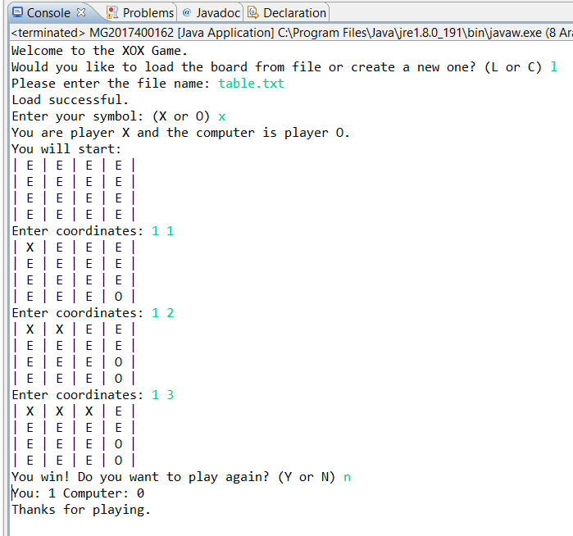
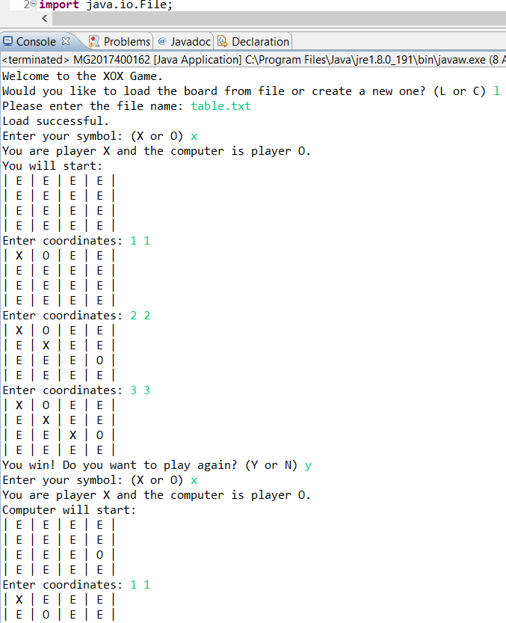
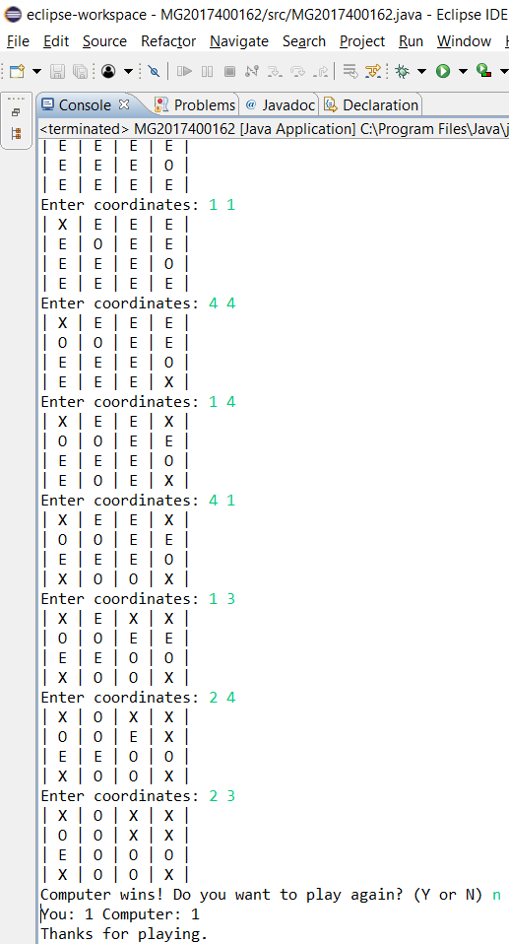

Conclusion: I have written this game correctly, but it is hard to accomplish all errors and exceptions. I tried many coordinates and combinations of values. All of these cases my program run correctly.

